Rental Agreement
For the Common Space at
105 S. Franklin Street
Titusville, PA 16354
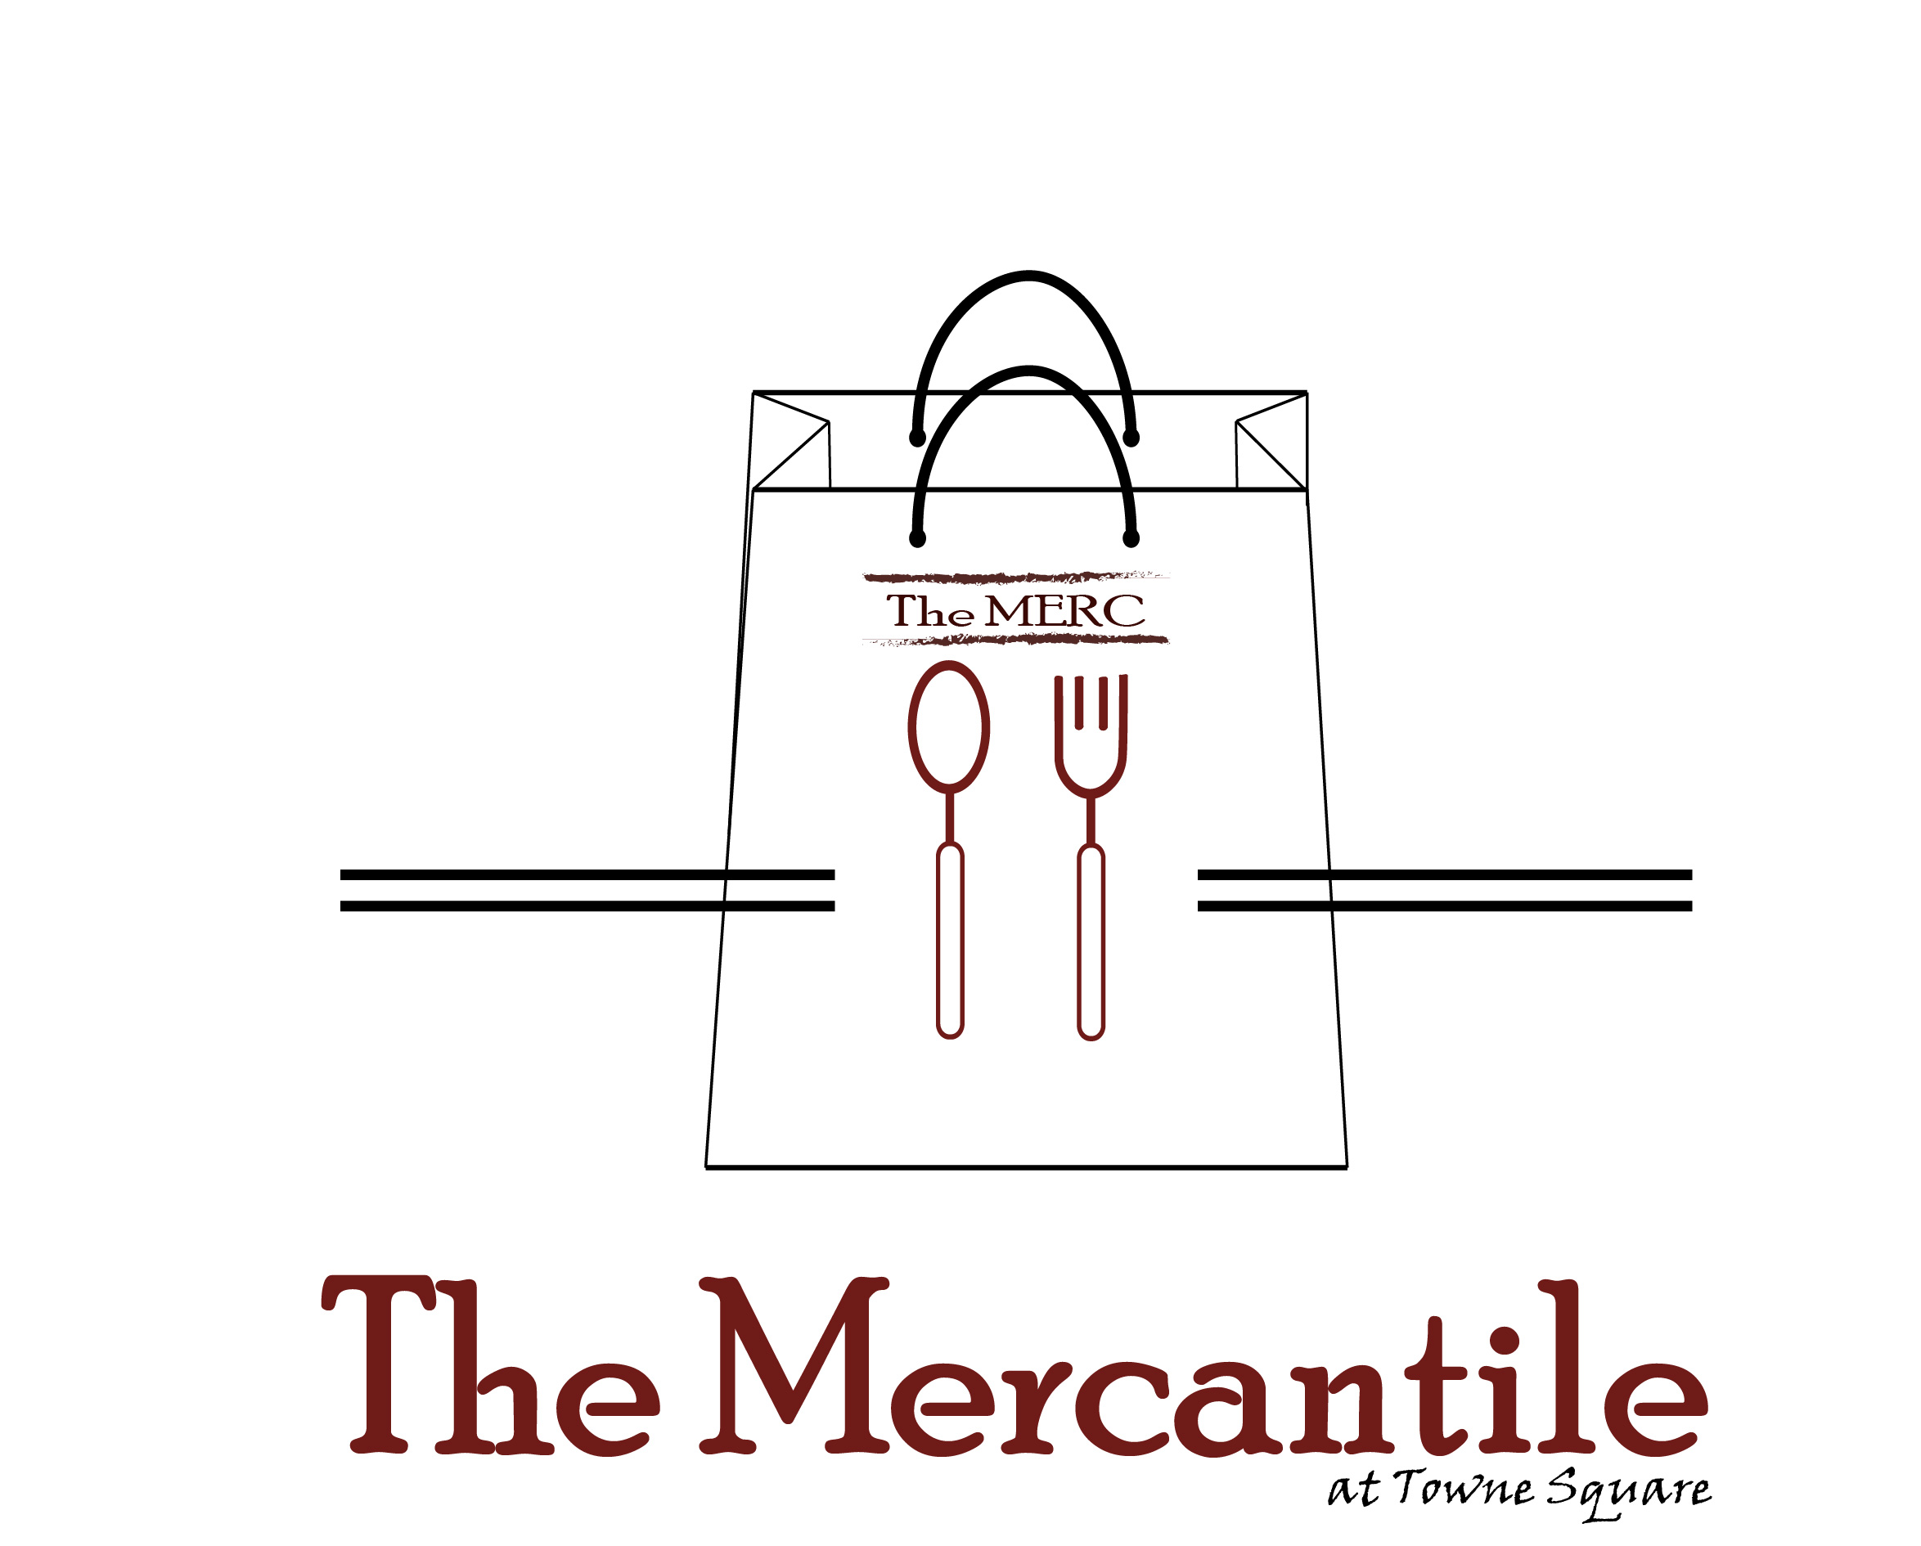

Name: Click or tap here to enter text.

Email: Click or tap here to enter text. Phone:Click or tap here to enter text.

Address: Click or tap here to enter text.

City: Click or tap here to enter text. State: Click or tap here to enter text. Zip Code: Click or tap here to enter text.

Rental Date(s): Click or tap here to enter text.

Rental Time: Click or tap here to enter text. Earliest Arrival Time: Click or tap here to enter text.

Reason for Rental: Click or tap here to enter text. Attendance: Click or tap here to enter text.(Maximum is 40 people)

RATES*
- RENTAL: $200.00 which includes a $50 refundable deposit in case of damages.

HOURS AVAILABLE*
- Monday – Wednesday: 5 PM – 8 PM
- Saturday – Sunday: 3 PM – 8 PM

DETAILS*
- Renter is responsible for their own party supplies such as: decorations, plates, napkins, etc.
- Renter is responsible to clean up after the party. Please don’t leave garbage or food in the common space. There is a dumpster available to dispose of your trash.
- The Merc will provide trash cans and cleaning supplies.
- Please do not move any existing Merc decorations or touch things outside of the stores.
- If renter is interested in having Coffee Days or Curbside or the Ice Cream Store cater, please contact them directly.

Reservations can be made through:
Kaleb Lewis at the Fallen Shoppe – fallenthreadsco@gmail.com

Room rental is not complete until all parties sign below:

Renter: ____________________________________________________ Date: _________________

The Merc: _______________________________________________ Date: __________________

Mailing Address:
TCDA Please make checks payable to: The Fallen Industry
110 W. Spring Street, Ste 200 Memo Line: “Merc Rental”
Titusville, PA 16354

